

THE 6th VGIK INTERNATIONAL SUMMER SCHOOL

Rules and Regulations

1. Introduction.

The 6th International Summer School (from July 11th till August 1st, 2014) Svetlogorsk, Russian Federation is organized by:
• Russian State University of Cinematography n.a. S.Gerasimov (VGIK),

under the patronage of :
• Ministry of Culture of the Russian Federation,
• Ministry of Culture of Kaliningrad Region.

2. The aim of the school is:

- to acquire additional knowledge and training in the profession,
- to develop academic and creative film production contacts between the students of film schools from different countries,
- to exchange the knowledge and experience in the field of the film education.

3. The academic and film production activities.

Within the framework of the summer school the students of Direction, Cinematography, Film production departments of film schools will get together in the City of Svetlogorsk (Kaliningrad Region) to:

• attend master-classes of European and Russian filmmakers,
• present and discuss their stories on the proposed theme,
• explore the area of the shooting,
• receive an expertise and professional advice of the masters at all stages of film production,
• shoot a 10-minute documentary film on the theme «Amber region: Past and Future».

4. The language of the School: English.

5. The dates of the School activities: from July 11th till August 1st, 2014.

6. To participate please submit by May 27, 2014 as follows:

• filled-in application form,
• electronic photo,
• trailer of the film shot during studies at their schools (documentary or feature, subtitled in English) or the link for a video,
• synopsis or notes explaining the intention and your vision of the story to be shot in Kaliningrad Region,
• letter of recommendation from your school.

7. The terms of staying:

a) VGIK provides:
• board and lodging for the participants,
• equipment and materials for film production (mini DV-format),
• transportation costs within the Russian Federation,
• a DVD with the collection of films made by Summer School participants.

b) The participants pay for:
• round-trip ticket to Svetlogorsk (Kaliningrad Region), Russia,
• cost of obtaining entry visa to Russia,
• international travel health insurance.

8. Contacts:

RUSSIAN STATE UNIVERSITY OF CINEMATOGRAPHY named after S. Gerasimov (VGIK)

W. Pieck str. 3, Moscow, 129226-RU
International Affairs Department: (499) 181 26 80;
Fax: (499) 181 80 74;
E-mail: foreign_vgik@mail.ru

RUSSIAN STATE UNIVERSITY OF CINEMATOGRAPHY named after S. A. Gerasimov (VGIK)
W. Pieck str. 3, Moscow, 129226-RU
International Contact: (499) 181 17 60; 181 26 80; Fax (499) 181 80 74;
E-mail: foreign_vgik@mail.ru

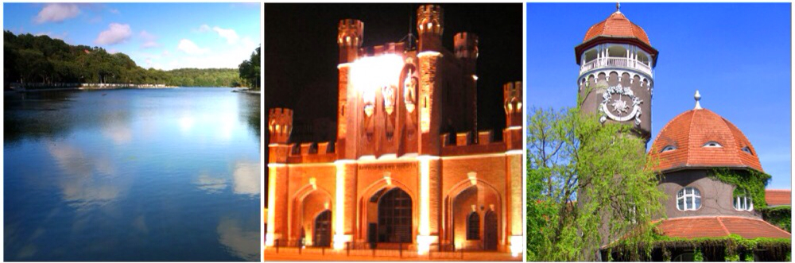
Ozero Tihoe, Svetlogorsk King's Gate, Kaliningrad Vodonapornaya bashnya, Svetlogorsk

